

SAVEETHA SCHOOL OF ENGINEERING
SAVEETHA INSTITUTE OF MEDICAL AND SCIENCES
CHENNAI-602105
INSTITUTE OF ARTIFICIAL INTELLIGENCE AND DATA SCIENCE
DEPRATMENT OF DATA SCIENCE
Course code/Name: CSA08/ Python Programming
- Write a python program using function to calculate the simple interest. Suppose the customer is a senior citizen. He is being offered 12 percentage rate of interest; for all other customers, the ROI is 10 percentage.
Sample Input:
Enter the principal amount: 200000
Enter the no of years: 3
Is customer senior citizen (y/n): n
Sample Output:
Interest: 60000 Test Cases:
  - Principal: 2000 , Years: 0
  - Principal: 20000 , Years: -2
  - Principal: -2000 , Years: 2
  - Principal: 2 , Years: 2000
  - Principal: 0 , Years: 5
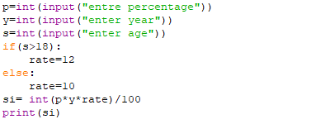
- Write a Python function sum square(l) that takes a nonempty list of integers and returns a list [odd,even], where odd is the sum of squares of all the odd numbers in l and even is the sum of squares of all the even numbers in l.
Sample Input:
Enter the number of elements:7
Enter the element: 18
Enter the element: 9
Enter the element: 1
Enter the element: 12
Enter the element: 13
Enter the element: 4 Enter the element: 30
Output:
[251, 1384] Test Cases:
- 5, [1,2,3,4,5]
- 8, [2,4,5,6,7,11,12,13]
- -1, [12,10,11,1,2]
- 0, [1,2,3,4,5]
- -8, [2,4,5,6,7,11,12,13]
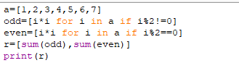
3. Maximum Number of Words Found in Sentences
A sentence is a list of words that are separated by a single space with no leading or trailing spaces. You are given a list of strings sentences, where each sentences[i] represents a single sentence. Write a python program to return the maximum number of words that appear in a single sentence Test Cases:
1. Input: sentences = ["alice and bob love apple", "I think so too", "this is great thanks very much"]
Output: 6
- Input: sentences = ["please wait", "continue to fight", "continue to win"]
Output: 3
- [“the heads”, “of”, “two”, “sorted linked lists”]
- [“python” , “is”, “an object-oriented programming language”]
- [“python”, “is”, “an interactive language”]
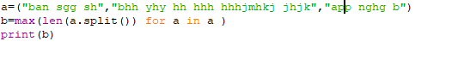
as numeric data | type
4. Given an integer x. write a python program to return true if x is palindrome integer.
An integer is a palindrome when it reads the same backward as forward. For example, 121 is a palindrome while 123 is not.
Test cases:
1.Input: x = 121
Output: true
Explanation: 121 reads as 121 from left to right and from right to left.
2.Input: x = -121 Output: false
Explanation: From left to right, it reads -121. From right to left, it becomes 121-. Therefore it is not a palindrome.
3.Input: x = 10
Output: false
Explanation: Reads 01 from right to left. Therefore it is not a palindrome.
4.x=abc
5.x=0
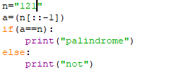
- Write a python program to print the numbers from M to N by skipping K numbers in between? Get the input using list data type.
Sample Input:
  - = 50
  - = 100
K = 7
Sample Output:
50, 58, 66, 74, ….. Test cases:
  - M = 15, N = 05, K = 02
  - M = 25, N = 50, K = 04
  - M = 15, N = 100, K = -02
  - M = 0 , N = 0 , K = 2
  - M = 200 , N = 200 , K = 50
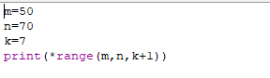
- Most years have 365 days. However, the time required for the Earth to orbit the Sun is actually slightly more than that. As a result, an extra day, February 29, is included in some years to correct for this difference. Such years are referred to as leap years.
The rules for determining whether or not a year is a leap year follow:
Any year that is divisible by 400 is a leap year.
Of the remaining years, any year that is divisible by 100 is not a leap year.
Of the remaining years, any year that is divisible by 4 is a leap year.
All other years are not leap years.
Write a python program that reads a year from the user and displays a message indicating whether or not it is a leap year.
Sample Input: Enter Date : 1947 Sample Output:
Given year is Non Leap Year
Leap Year: 1944 Test cases:
1. 19.47

2. 1936
3. 0

4. 2000
5. -1428
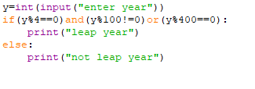
7. Write a python program to print the following pattern.
Sample Input: Number of rows:5 Sample output:
1
- 15
- 2 1
- 3 2 1
- 4 3 2 1 Test cases: 1) 0
- -1
- 4.5
- 6
- 5
- Merge Two Sorted Lists
You are given the heads of two sorted lists list1 and list2.
Constraints:
  - The number of items in both lists is in the range [0, 50].
  - Both list1 and list2 are sorted in non-decreasing order.
Test cases:
1.Input: list1 = [1,2,4], list2 = [1,3,4]
Output: [1,1,2,3,4,4]
2.Input: list1 = [], list2 = []
Output: []
3.Input: list1 = [], list2 = [0]
Output: [0]
4.list1=[],list2=[1,2,3,4,5]
5.list1=[0,1,9], list2=[3,4,5]
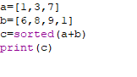
- Write a python program for matrix addition using nested list?
Sample Input:
Mat1 = 1 2 5 3
Mat2 = 2 3
4 1
Sample Output:
Mat Sum = 3 5
9 4
Test Cases:
  - Mat1=[7,-1,5,4], Mat2=[2, 5 , 4, 3]
  - Mat1=[4,8,3,7], Mat2=[1,0,5,2]
  - Mat1=[4,8,3,7], Mat2=[1,0,5,2, 5, 6]
  - Mat1=[3,-4,8,5], Mat2=[9,-5,6,-6]
  - Mat1=[0,0],Mat2=[0,0,0,0]
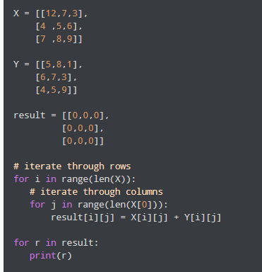
- The Project manager has to submit the project within a week period. He didn’t find the proper combinations of team members to work on the project, Help him in finding the possible combinations available.
Write a python program to Accept 3 digits and find all the combinations Sample Input:
123
Sample Output:
123
132
213
231
312
321
Test Cases:
1.789
2.1456
3.-856
4.1001
5.555
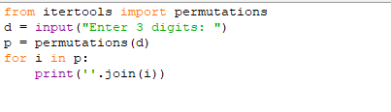
11. Write a python program that would sort a list of names in alphabetical order Ascending or Descending, choice get from the user?
Sample Input:
Banana
Carrot
Radish
Apple
Jack
Order (A/D): A Sample Output:
Apple
Banana
Carrot
Jack
Radish
Test cases:
- Zeebra, Abc, bank, apple, fruit
- Quick, Brown, fox, lazy, dog 3. python, Python, program
- red,yellow,green, blue, white
- toys, car, bike, truck, Doll
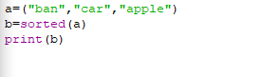
- Write a python program to print the number of vowels in the given string?
Sample Input:
Saveetha School of Engineering Sample Output:
Number of vowels = 12 Test cases:
  - India is my country
  - All are my brothers and sisters
  - Why dry sky
  - Shy Try Cry
  - EDUCATION
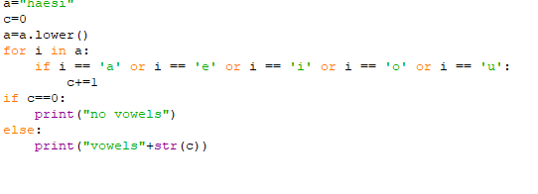
- Write a python program to find the square, cube of the given decimal number
Sample Input: Given Number: 0.6 Sample Output:
Square Number: 0.36
Cube Number: 0.216 Test cases:
  - 12
  - 0
  - -0.5
  - 14.25
  - -296
- Write a python program to find the number of student users in the college, get the total users, staff user’s details from the client. Note for every 3 staff user there is one Non-teaching staff user assigned by default. Sample Input:
Total Users: 856
Staff Users: 126 Sample Output: Student Users: 688 Test Cases:
- Total User: 0
- Total User: -143
- Total User: 1026, Staff User: 1026
- Total User: 450, Staff User: 540
- Total User: 600, Staff User: 450
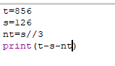
15. Write a python program to reverse a word using loop? (Not to use inbuilt functions) Sample Input: String: TEMPLE Sample Output:
Reverse String: ELPMET Test cases:
- SIGN UP
- AT-LEAST
- 1245
- !@#$%
- 145*999=144855
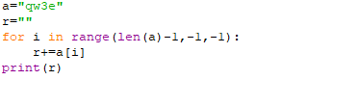
16. Write a python program to print the pattern
Enter the number of rows: 4
0.1
0.1 | 0.2
0.1 | 0.2 | 0.3
0.1 | 0.2 | 0.3 | 0.4
Test cases:
  - 0
  - -1
  - 4.5
  - 6
  - 5
nums | [i]
nums | [i]
j ! | = i | and | nums | [j] < | nums | [i]
17. How Many Numbers Are Smaller Than the Current Number? Given the list nums, for each find out how many numbers in the list are smaller than it. That is, for each you have to count the number of valid j's such that .
Return the answer in an list.
Test Cases:
1.Input: nums = [8,1,2,2,3] Output: [4,0,1,1,3] Explanation:
For nums[0]=8 there exist four smaller numbers than it (1, 2, 2 and 3).
For nums[1]=1 does not exist any smaller number than it.
For nums[2]=2 there exist one smaller number than it (1).
For nums[3]=2 there exist one smaller number than it (1).
For nums[4]=3 there exist three smaller numbers than it (1, 2 and 2).
- Input: nums = [6,5,4,8] Output: [2,1,0,3]
- Input: nums = [7,7,7,7]
Output: [0,0,0,0]
4.nums=[1,2,3,5,5,6]
5. nums=[0,0,0,0]
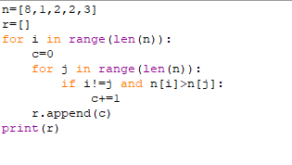
17. Write a python program to find the Mean, Median, and Mode of the list of elements?
Sample Input;
List of elements = [16, 18, 27, 16, 23, 21, and 19] Sample Output:
Mean = 20
Median = 19
Mode = 16
Test cases:
- List of elements = [26, 28, 37, 26, 33, 31, 29]
- List of elements = [1.6, 1.8, 2.7, 1.6, 2.3, 2.1, .19]
- List of elements = [0, 160, 180, 270, 160, 230, 210, 190, 0]
- List of elements = [200, 180, 180, 270, 160, 270, 270, 190, 200]
- List of elements = [100, 100, 100, 100, 100, 100, 100, 100, 100]
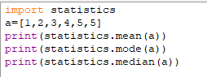

19. Write a python program to print consonants and vowels separately in the given string
Sample Input:
Given Word: Engineering Sample Output:
Consonants: n g n r n g
Vowels: e i e ei Test cases:
- TRY
- MEDIAN
- ONE
- KNOWLEDGE
- EDUCATION
20.Write a python program to reverse a number using loop?(Get the input from user) Sample Input:
Number: 14567 Sample Output: Reverse Number: 76541 Test cases:
- -45721
- 000
- AD1947
- !@#$%
- 145*999=144855
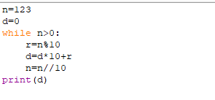
21. Given a string s consisting of words and spaces, return the length of the last word in the string.A word is a maximal substring consisting of non-space characters only.
Test Case:
Input: s = "Hello World"
Output: 5
Input: s = " fly me to the moon "
Output: 4
Input: s = "luffy is still joyboy"
Output: 6
Input: s = "123"
Output: 3
Input: s = " 45&29 8*6^4" Output: 5
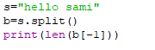
22. Write a python program to print all the composite numbers between a and b? Sample Input:
- = 12
- = 19
Sample Output
14, 15, 16, 18
Test cases:
- A = 11, B = 11
- A = 20, B = 10
- A = 0, B = 0
- A = -5, B = 5
- A = 7, B = -12
- In an organization they decide to give bonus to all the employees on New Year. A 5% bonus on salary is given to the grade A workers and 10% bonus on salary to the grade B workers. Write a python program to enter the salary and grade of the employee. If the salary of the employee is less than $10,000 then the employee gets an extra 2% bonus on salary Calculate the bonus that has to be given to the employee and print the salary that the employee will get.
Sample Input & Output:
Enter the grade of the employee: B
Enter the employee salary: 50000
Salary=50000
Bonus=5000.0
Total to be paid:55000.0

Test cases:
  - Enter the grade of the employee: A Enter the employee salary: 8000
  - Enter the grade of the employee: C Enter the employee salary: 60000
  - Enter the grade of the employee: B Enter the employee salary: 0
  - Enter the grade of the employee: 38000 Enter the employee salary: A
  - Enter the grade of the employee: B Enter the employee salary: -8000
  - 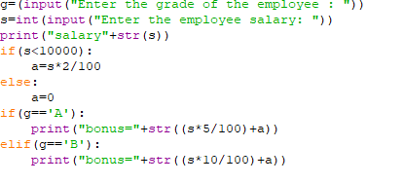
- Write a python program to find the LCM and GCD of n numbers?
Sample Input:
N value = 2
Number 1 = 16
Number 2 = 20 Sample Output:
LCM = 80 GCD = 4
Test cases:
    - N = 3, [12, 25, 30]
    - N = 2, [52, 25, 63]
    - N = 3, [17, 19, 11]
    - N = -2, [52, 60]
    - N = 2, [30, 45]
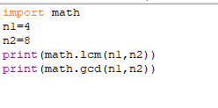
- Write a python Program to find the frequency of each element in the list.
Sample Input & Output:
[1, 2, 8, 3, 2, 2, 2, 5, 1]
Element | Frequency
-------------------------1 | 2
2 | 4
8 | 1
      - | 1
      - | 1
Test Cases:
- [9,10,8,3,4,5,9,8]
- [1, 2, 4, 2, 5, 2, 5, 1]
- [91,10,81,33,44,55,91,81,44]
- [0.1,0.2,0.1,0.3,0.4,0.2,0.1]
- [-1, -2, 4, -2, 5, 2, 5, -1]
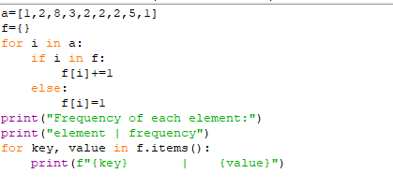
26.Write a python program to calculate Pow(x,n), Add(x,n), Sub(x,n), Mul(x,n), Div(x,n)? Get the input and choice from the user.
Sample Input:
X = 2
N = 4
Choice : 2 Sample Output:
Add(X,N) = 6 Test cases:
- X = 0 , N = 4
- X = 5 , N = 0
- X = -3 , N = 3
- X = 0 , N = 0
- X = 123, N = 123
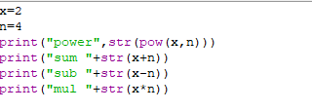
27. Little Robert likes mathematics. Today his teacher has given him two integers and asked him to find out how many integers can divide both the numbers. Would you like to help him in completing his school assignment?
Test Cases:
- Enter the numbers: 4, 12
Output: 4
- 4, 8
- -10,0
- 12,34
5.16,17
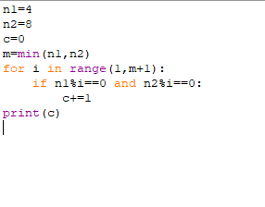
28.Write a python program to count all the prime and composite numbers entered by the user.
Sample Input:
Enter the numbers
4
54
29
71
7
59
98
23
Sample Output:
Composite number: 3
Prime number: 5 Test cases:
- 33, 41, 52, 61,73,90
- TEN, FIFTY, SIXTY-ONE, SEVENTY-SEVEN, NINE
- 45, 87, 09, 5.0 ,2.3, 0.4
- -54, -76, -97, -23, -33, -98
- 45, 73, 00, 50, 67, 44
29. Write a python program to find whether the person is eligible for vote or not. And if that particular person is not eligible, then print how many years are left to be eligible.
Sample Input:
Enter your age:
7
Sample output:
You are allowed to vote after 11 years Test cases:
- 25
- Eighteen
- 12
- -18
- 34.5
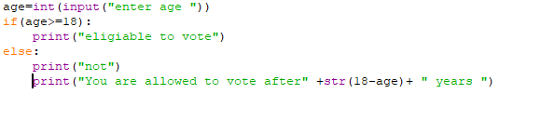
30. Write a python program to print the following pattern Sample Input:
Enter the Character to be printed: %
Max Number of time printed: 3
%
%%
%%%
Test case:
  - 1,0
  - -1,-1
  - $,5
  - ^,7
  - @,-1
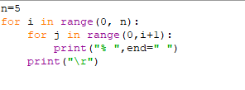
31.Write a python program to print the given number is Perfect number or not?
Sample Input:
Given Number: 6
Sample Output:
Its a Perfect Number Test cases:
- 17
- 26!
- 143
- 84.1
5.963
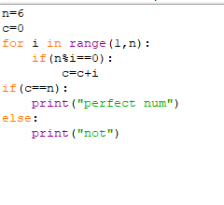
32.Write a python program to print the following pattern.
Enter the number of rows:4

1
2 3
4 5 6
7 8 9 10

- 0
- -1
- 6
- 0.25) 10
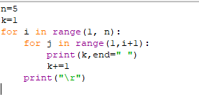
33. Write a python program to find the factorial of n?
Sample Input:
N = 4
Sample Output: 4 Factorial = 24 Test cases:
- N = 0
- N = -5
- N = 1
- N = Q
- N = 3A
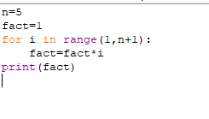
- Write a python program to find the n^{th} odd number after n odd number
Sample Input:
N : 4
Sample Output:
4th Odd number after 4 odd numbers = 15 Test cases:
  - N = 0
  - N = -6
  - N = 2021
  - N = -14.5
  - N = -196
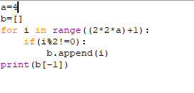
- Write a python program to enter the marks of students in four subjects. Then calculate the total and aggregate, display the grade obtained by the student. If the student scores an aggregate greater than 75%, then the grade is distinction. If aggregate is 60>= and <75, then the grade if First Division. If aggregate is 50>= and <60, then the grade is second division. If aggregate is 40>= and <50, then the grade is third division. Else the grade is fail.
Sample input & output
Enter the marks in python: 90
Enter the marks in c programming: 91
Enter the marks in Mathematics: 92
Enter the marks in physics : 93
Total : 366
Aggregate: 91.5 Distinction Test cases:
  - 18,76,93,65
  - 73,78,79,65
  - 98,106,120,95
  - 96,73,-85,95
  - 78,59.8,76,79
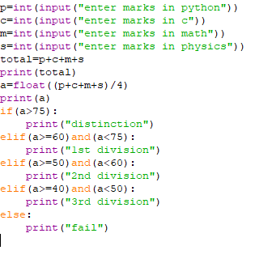

- Write a python program to arrange the letters of the word alphabetically in reverse order
Sample Input:
Enter the word: MOSQUE Sample Output:
Alphabetical Order: U S Q O M E Test Case:
  - HYPOTHECATION
  - MATRICULATION
  - MANIPULATION
  - SATISFACTION
  - DEDICATION
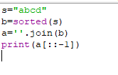
- Write a python program to print the pattern
Enter the number of rows: 5
1
12
123
1234
12345
Test Case:
- 0
- -1
- 6
- 0.2
- 10
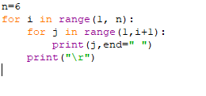
- Write a python program to convert the binary to decimal, octal, get the choice from the user.
Sample Input:
Given number: 1101 Conversion (D/O): D Sample output:
Decimal number: 13
Test cases:
  - 211, D
  - 1101,O
  - 22111,O
  - 111011.011,D
  - 101010,H
Binary to decimal
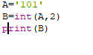
Binary to octal
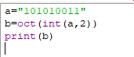
- Write a python program to find the number of factors for n?
Sample input:
N=6
Sample output:
Number of factors for 6: 4 Test cases:
  - N=0
  - N=-5
  - N=1
  - N=20
  - N=3A
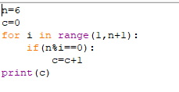
- Write a program to Swap two numbers (1) with temp variable (2)without using temp variable (3) using tuple assignment.
Sample input:
A=4
B=6
After swapping A=6 B=4
Test cases:
  - A,0
  - 4,5
  - 7,-7
  - 0,0
  - 5,7

- Asci

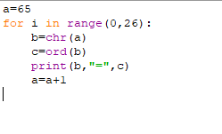
- Armstrong

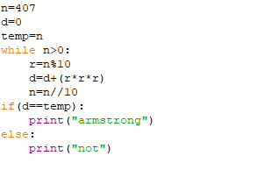
43.palindrome
Using loop
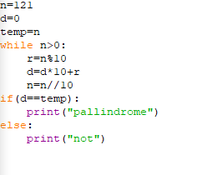
Without loop

44 remove duplicate
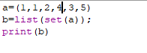
45 lsd and msd
